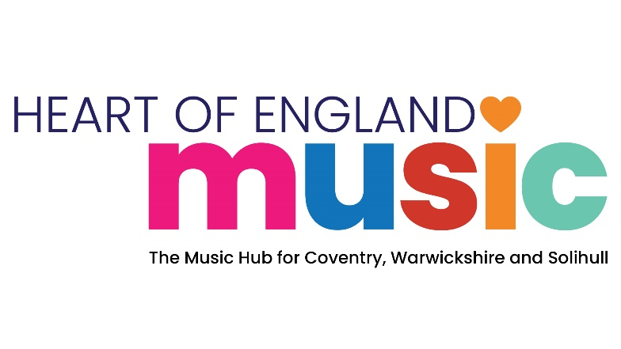

Music Hub Funding Application

**Part 1: Funded Programme Specification**

**Programme Title: Inclusive Contemporary Music Programme**

|  |  |
| --- | --- |
| **Funding and Delivery Specification** | |
| **Locality:** | Warwickshire Local Authority Area |
| **Setting:** | Community setting |
| **Music Hub Funding Available:** | Up to £5,000 |
| **Funding Period:** | January to August 2025 (spring & summer terms) |
| **Application Closing date:** | 3rd January 2025 |
| **Completed application return to:** | [richardhart@warwickshire.gov.uk](mailto:richardhart@warwickshire.gov.uk) |
| **Programme Scope:** | |
| We are seeking an experienced and innovative organisation who can work with Heart of England Music to provide a community based contemporary music programme that will enable vulnerable and hard to reach young people to make and create music in Warwickshire. Particular consideration will be given to applications who are able to support young people who have SEMH and special educational needs and disabilities.  We are very interested to hear from organisations who can build upon and extend their existing offer to provide either weekly or project-based delivery opportunities through the spring and summer terms 2025 that may include Rock & Pop groups, Music Production and/or DJ’ing activity leading to performances that enable young people to share and celebrate their achievements through music video and/or live performance events. | |
| **Additional programme information and requirements:** | |
| The funded Delivery Partner will be required to:   * Match the level of Music Hub Funding available for this programme in cash or in-kind terms to enhance the programme scope. * Have, and fully fund a remissions policy where charges are made directly to young people or their families at point of access. * Establish a data sharing agreement with Heart of England Music. * Provide performance videos from the programme to be shared on the Music Hub and Warwickshire Music’s website and social media channels. * Acknowledge support from, and display the Heart of England Music, Warwickshire Music and Arts Council Logos on all programme literature, marketing and delivery materials. * Support Music Hub Events through the 2024-2025 Academic Year if required. | |
| **Reporting and data capture requirements:** | |
| Funded Delivery Partner will be required to:   * Provide a short written report on the scope and impact of their delivery in Warwickshire for the Music Hub Board in June 2025. * Provide student engagement and financial data for their work in Warwickshire in line with Arts Council England Music Hub reporting requirements in July 2025. * Work closely with Warwickshire Music’s Parentships Manager, meeting at least termly to ensure the success of the partnership and delivery of the programme. | |

**Part 2: Funding Application Form**

**Programme Title: Schools Live Music Programme**

|  |  |
| --- | --- |
| **Organisation Name:** |  |
| **Postal Address:** |  |
| **Website:** |  |
| **Principal Contact Name:** |  |
| **Principal Contact Email:** |  |
| **Principal Contact Telephone:** |  |
| **Is your Organisation a Heart of England Music Member Organisation** | **Yes/No** |
|  |  |
| **Level of Music Hub Funding applied for (up to £5,000 max.)** |  |

|  |
| --- |
| **1. Tell us about your organisation and its track record of delivering opportunities and outcomes that align with the requirements of the programme scope. (500 word max.)** |
|  |
| **2. Tell us how the programme will be planned, managed and delivered to meet the programme scope and additional requirements.  This should include the number /duration of planned delivery sessions, the estimated number of young people engaged, the performance events you plan to provide. (1000 words Max)** |
|  |
| **3. Please provide detail of the match funding (cash and/or in-kind) you will bring to the programme and how it will be used. (200 words max.)** |
|  |
| **4. Tell us how the programme will be developed and sustained beyond the funding period. (500 words max.)** |
|  |
| **5. Tell us how your delivery is quality assured (300 words max.)** |
|  |
| **6. Tell us how safeguarding and Health & Safety matters will be managed and reported.** **(500 words max.)** |
|  |
| **7. Tell us how impact and outcome data will be captured and reported to us. (500 words max.)** |
|  |
| **8. If your application is successful, do you agree to enter into a data sharing g agreement with Heart of England Music?** |
| Yes/No |
| **9. Is there anything else you would like to tell us to support your application? (500 words max.)** |
|  |

**End**